**PRCS252 – Travel Management System Software:**

**User Story Analysis**

Driver:

1. As a driver, I want to be able to log in to the system, so that the service can start.
2. As a driver, I want to be able to access the shift schedule, so that I know when I need to work.
3. As a driver, I want to be able to view current stock, so that the number of coaches available to drive in the depot is known.
4. As a driver, I want to be able to access the coach service based on coach licence/service ID, so that the service can start.
5. As a driver, I want to be able to see the bookings made for a journey, so I know how many people will board the coach.
6. As a driver, I want to be able to start a service for a valid route, so that I can provide the travel product for customers.
7. As a driver, I want to be able to stop a service for a valid route, so that I can provide the travel product for customers.
8. As a driver, I want to be able to notify of breakdowns, so that a replacement coach will be called to assist passengers.
9. As a driver, I want to be able to view the set route for the journey, so that the coach can arrive at the destination.
10. As a driver, I want to be able to accept a e-ticket booking reference from a passenger, to validate their journey on the coach.
11. As a driver, I want to be able to view coach capacity, so that the maximum number of passengers can be ascertained.
12. As a driver, I want to be able to view remaining seats, so that the amount of spare room can be ascertained.

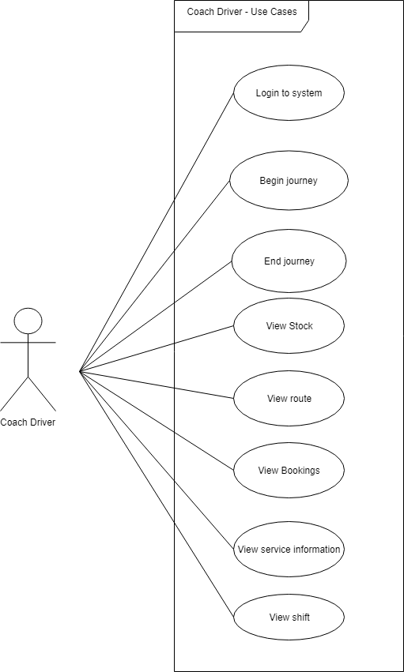

**Figure 1:** Use Case Diagram for drivers (using the desktop application)

Customer:

1. As a customer, I want to be able to create an account, so that I can book a place on a coach.
2. As a customer, I want to be able to select the day and time in which I want to travel, so that available services during those times will be available for me to book.
3. As a customer, I want to be able to search for timetabled routes given the starting point and destination.
4. As a customer, I want to be able to know the estimated time of the journey, so I know when the coach will get to my destination.
5. As a customer, searching for routes, I want to see fares and associated times for a journey, so that I can make sure I book the right journey for me.
6. As a customer, I want to be able to create bookings, so that I can catch the coach to my desired destination.
7. As a customer, I want to be able to make multiple bookings, so that I can travel with others.
8. As a customer, I want to be able to pay via PayPal, so I can confirm my travel.
9. As a customer, I want to be able to know my starting station, so I can know where to board the coach.
10. As a customer, I want to be able to know my ending station, so I can know where to get off the coach.
11. As a customer, I want to be able to view all my currently booked tickets and be able to display my booking reference code to the driver upon coach entry.
12. As a customer, I want to be able to view my prior travel history, so I can easily track where I have been and make new journey’s based on prior ones.
13. As a customer, I want to be able to view my account details, so that I can check my information is correct.
14. As a customer, I want to be able to update my account details, so that my information can be up to date.
15. As a customer, I want to be able to request the termination of my account, so that I can stop using the service.

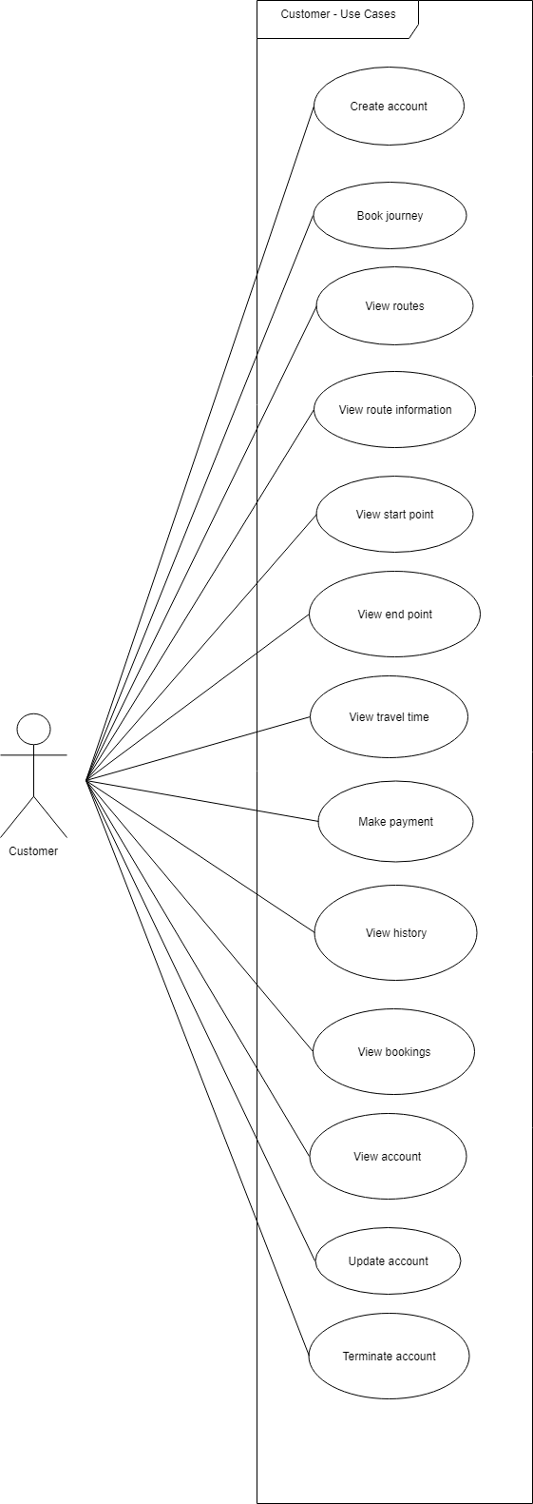

**Figure 2:** Use Case Diagram for customers (using the mobile application)

Admin:

1. As an admin, I want to be able to login to the system, so that I can perform my responsibilities within the system.
2. As an admin, I want to be able to approve customer account requests, so that customers can log in to their accounts.
3. As an admin, I want to be able to allow the changing of customer passwords, so that customers may alter their password.
4. As an admin, I want to be able to create employee accounts, so that new employees can undertake their duties.
5. As an admin, I want to be able to update employee accounts, so that information related to employees can be changed.
6. As an admin, I want to be able to retrieve employee accounts, so I can view information on employees.
7. As an admin, I want to be able to archive employee accounts, so that they are no longer active when an employee leaves the company.
8. As an admin, I want to create timetables for the routes, so that the routes and times can be documented.
9. As an admin, I want to update the timetables of routes, so that the routes and times can be amended.
10. As an admin, I want to retrieve the timetables of the routes, so that I can view the routes and times.
11. As an admin, I want to be able to archive the timetables of the routes, so that timetables can be decommissioned.
12. As an admin, I want to be able to create routes, so that coaches have a set path.
13. As an admin, I want to be able to update routes, in case a route needs to change.
14. As an admin, I want to be able to retrieve routes, so that I can view them.
15. As an admin, I want to be able to archive routes, so that that they can be decommissioned.
16. As an admin, I want to be able to create records of new coaches, so that the stock can be documented.
17. As an admin, I want to be able to view coaches in the stock inventory, so that I can ascertain what coaches are currently available.
18. As an admin, I want to be able to archive coaches in the stock inventory, so they can be decommissioned if not in use or replaced.
19. As an admin, I want to be able to deploy replacement services in the event of a coach breakdown, so we can assist passengers.

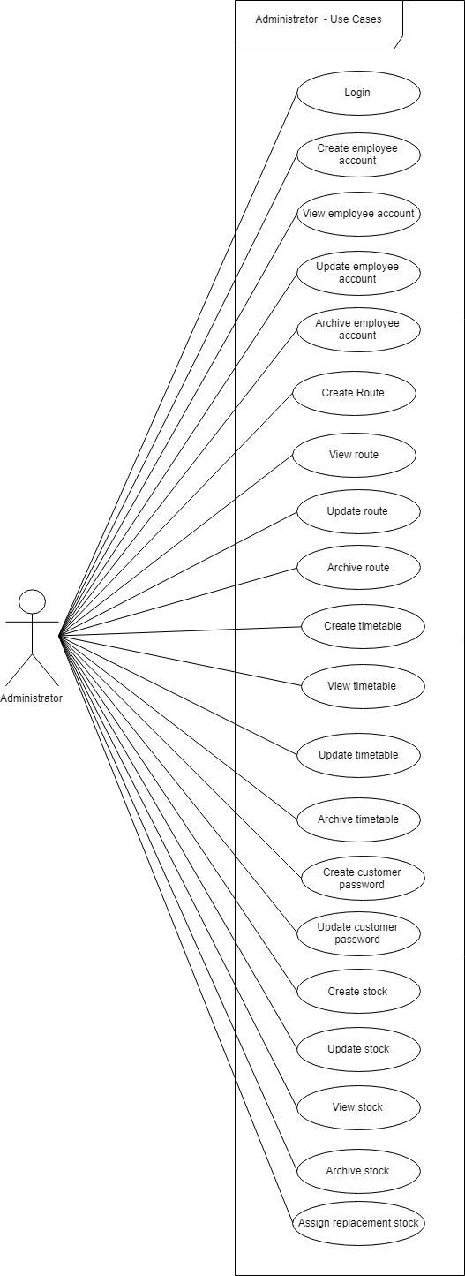

**Figure 3:** Use Case Diagram for administrators (using the web application)

Manager:

1. As a manager, I want to be able to view the drivers, so that I can see the driver’s that are available
2. As a manager, I want to be able to assign a driver a coach for the shift, so that the driver can perform his duties.
3. As a manager, I want to be able to update and make changes to a driver shift
4. As a manager, I want to be able to remove an employee’s shift, so that they no longer undertake that shift.
5. As a manager, I want to view all available routes, so that I can see what routes will need covering
6. As a manager, I want to view the timetables, so that I can see what time the routes are taken
7. As a manager, I want to assign a driver a route for their shift, so that the driver can take passengers to their destinations.

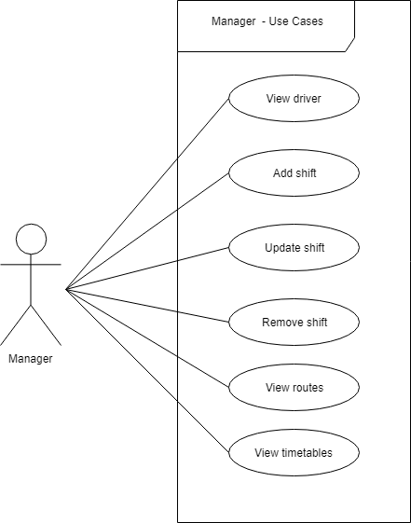

**Figure 4:** Use case diagram for manager (using the web application)